CO2- DEBUGGING
NAME: S.MAHALAKSHMI
REG NO: 192524372
COURSE:DATA STRUCTURE
COURSE CODE: CSA0311

Q1:
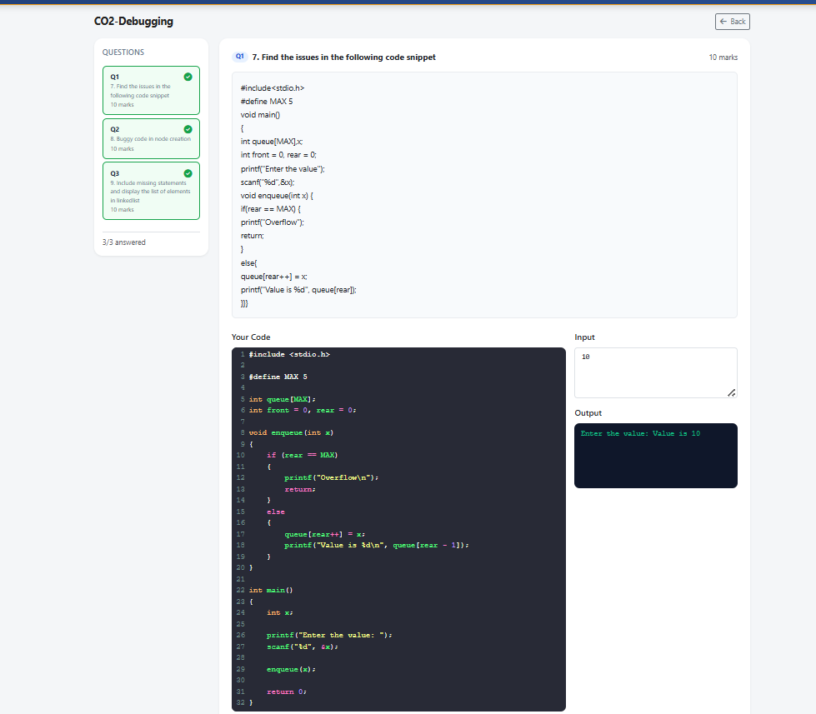

Q2:

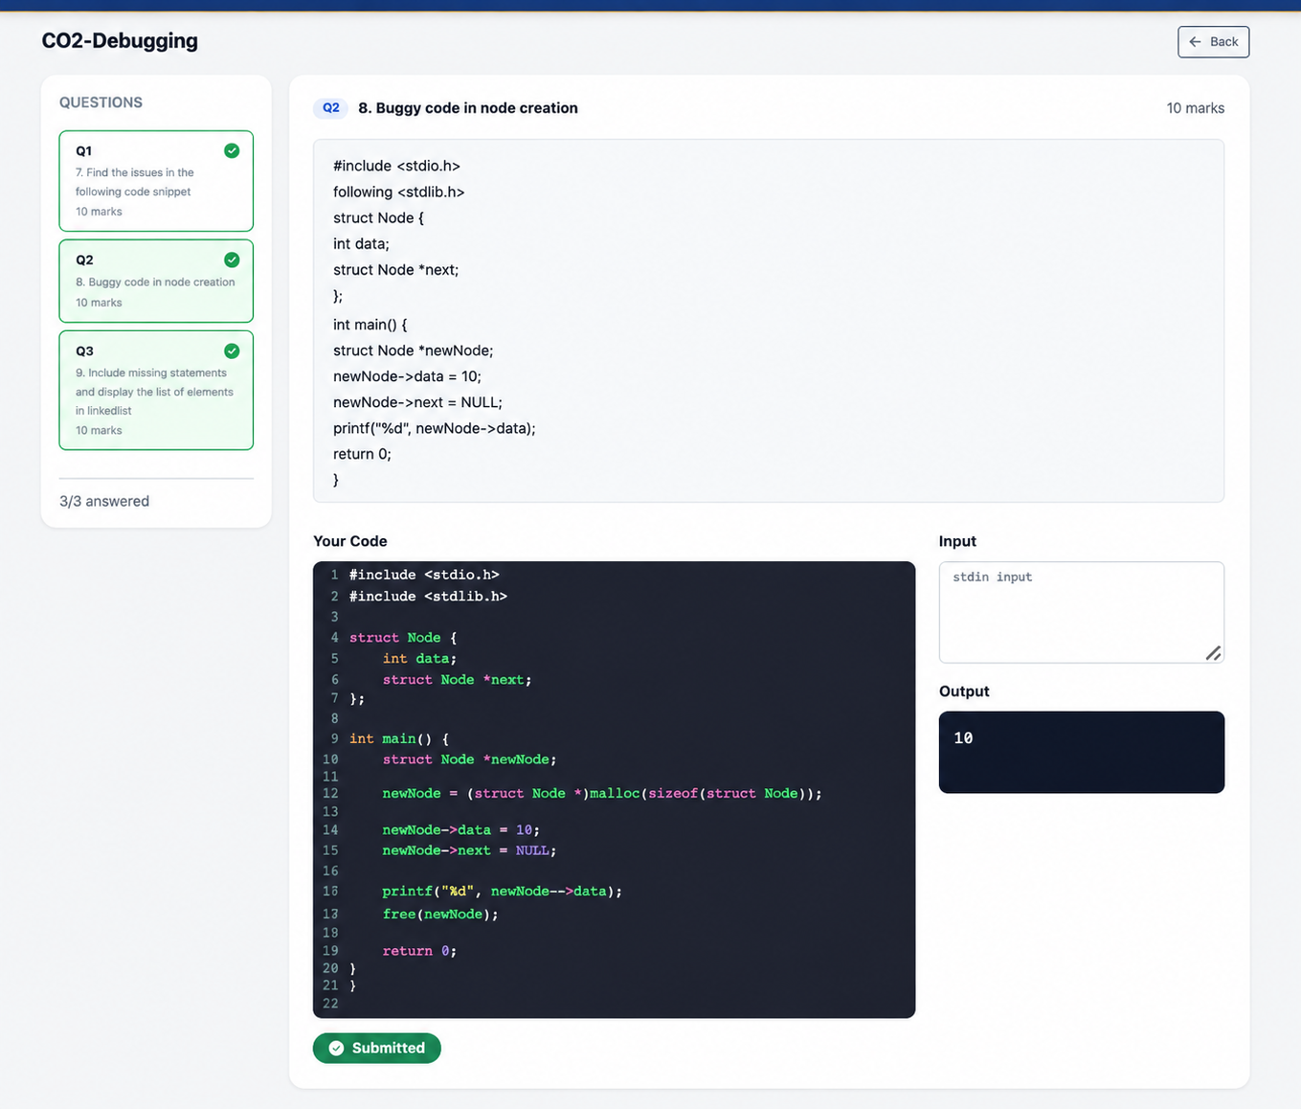

Q3:

